# CS 255 System Design Document Template

This template lays out all the different sections that you need to complete for Project Two. Each section has guidance to prompt your thinking. You will need to continually reference the interview transcript as you work to make sure that you are addressing your client’s needs. There is no required length for the final document. Instead the goal is to complete each section based on what your client’s needs are. Remove this note when you are finished, and replace all bracketed text with the relevant information.

## UML Diagrams

### UML Use Case Diagram

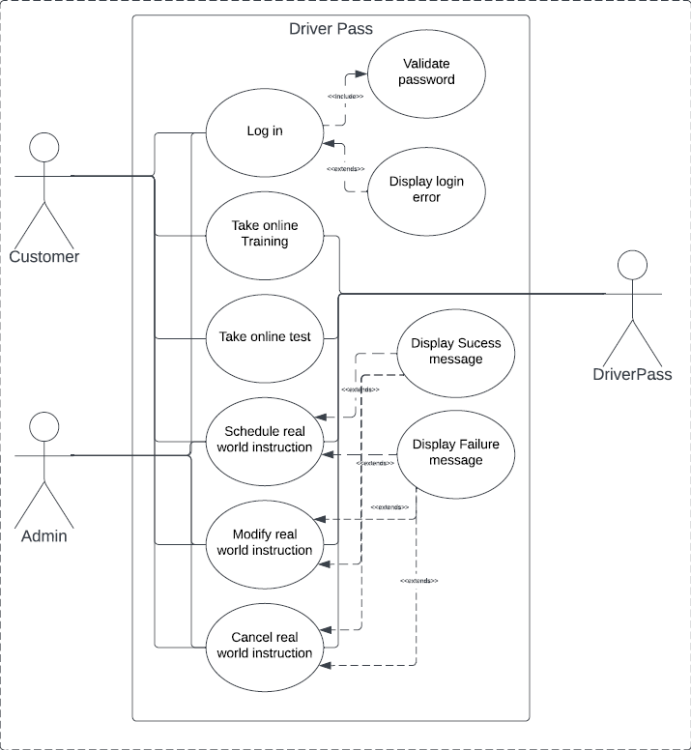

### UML Activity Diagrams

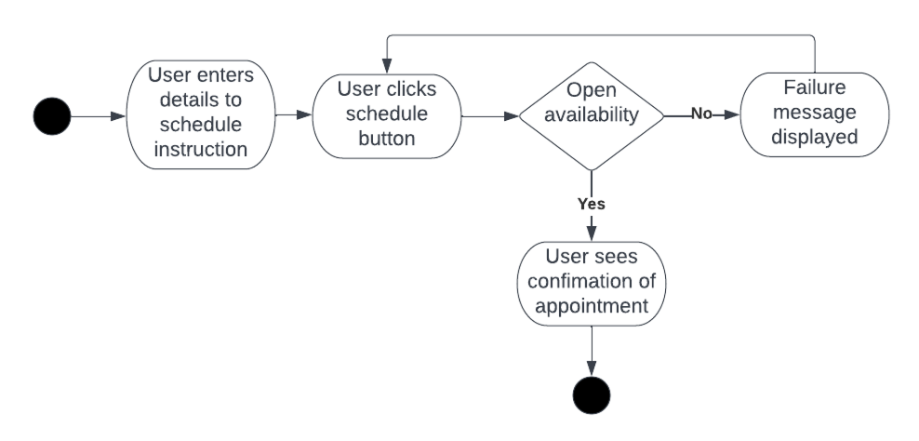

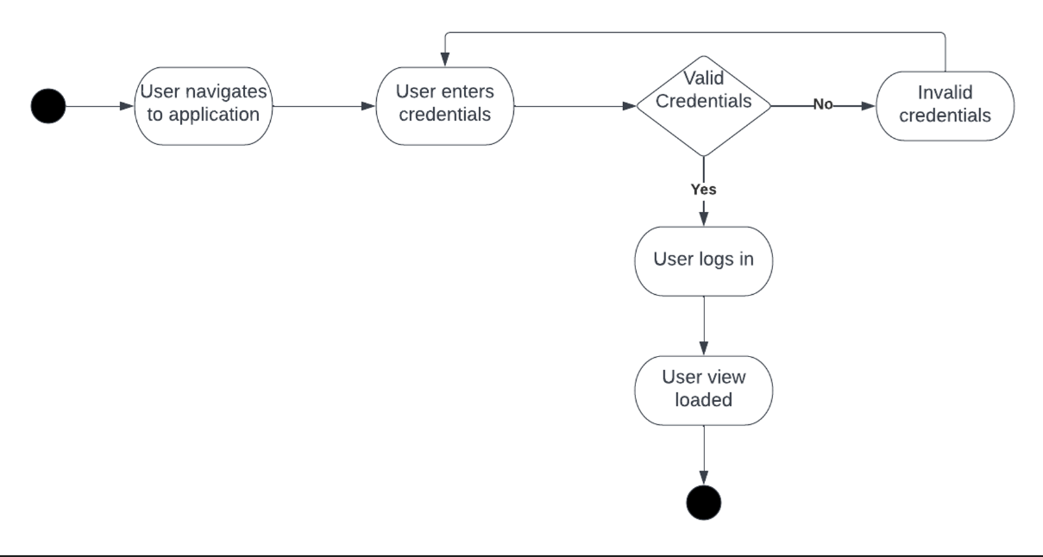

### UML Sequence Diagram

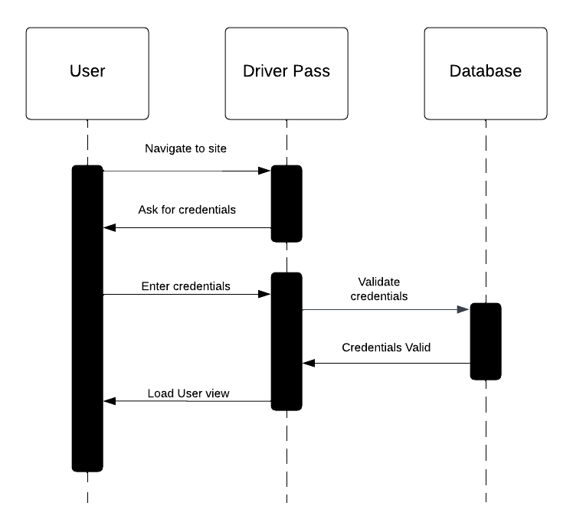

### UML Class Diagram

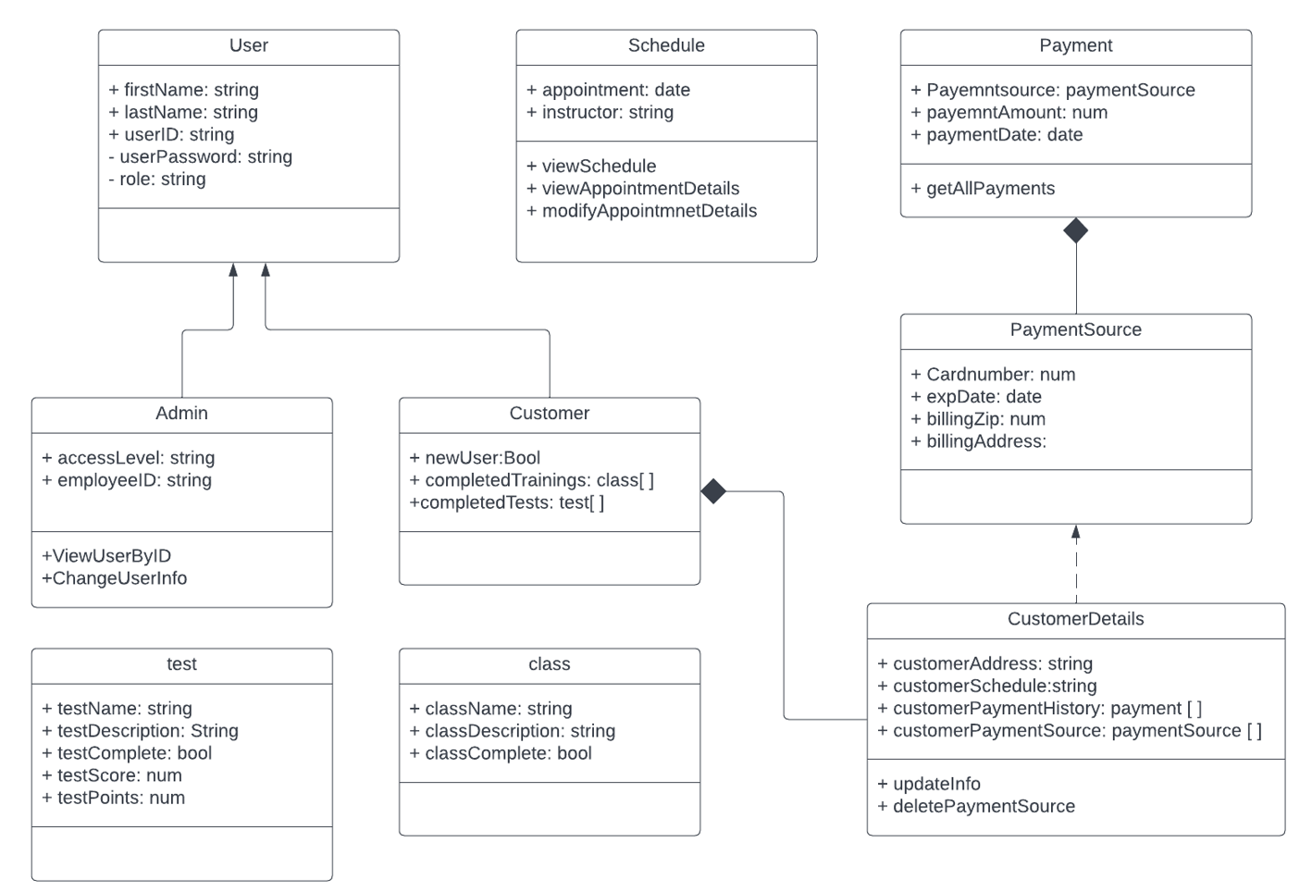

## Technical Requirements

* *The app should be able to run from any environment*
* *The application will run on all current android and apple devices*
* *The application will link securely to a database*
* *We will restrict access to database*
* *We will log all changes to customer data*
* *We will leverage JWT to securely access system*
* *We will host the app on a linux cloud server*
* *We will utilize Jenkins for CI/CD*
* *We will minimize downtime*
* *We will ensure adequate roles are in place for different access level*